# Measurable and Progress from maladaptive behaviors.

|  |  |  |  |  |  |
| --- | --- | --- | --- | --- | --- |
| Maladaptive Behaviors | Baseline Date:2017-07-08to2017-07-09 | Current average per week (3/31/2020) | % of Reduction(BL-average/ BL)*100 | Status | Updated STO (3/31/2020) |
| Tantrum | 28 incidents per weeks | 9 incidents per week. | 66% | In progress | Sto1(MASTERED 2018-03-03). Sto2(MASTERED 2018-05-26). Sto3(MASTERED 2018-12-22). Sto4(MASTERED 2019-10-19). Sto5(MASTERED 2020-01-10). Currently: STO 6(Initiated 2/1/2020) |
| Disruption | 21 incidents per weeks | 11 incidents per week. | 48% | In progress | Sto1(MASTERED 2018-05-05). Sto2(MASTERED 2019-10-05). Sto3(MASTERED 2019-12-30). Currently: STO 4(Initiated 1/1/2020) |
| Argumentative/Defiant Behavior | 35 incidents per weeks | 10 incidents per week. | 70% | In progress | Sto1(MASTERED 2018-05-19). Sto2(MASTERED 2018-11-03). Sto3(MASTERED 2019-11-16). Sto4(MASTERED 2020-02-07). Currently: STO 5(Initiated 3/1/2020) |
| Task Refusal | 28 incidents per weeks | 11 incidents per week. | 59% | In progress | Sto1(MASTERED 2018-02-03). Sto2(MASTERED 2018-10-20). Sto3(MASTERED 2019-01-12). Sto4(MASTERED 2019-10-12). Sto5(MASTERED 2020-01-10). Currently: STO 6(Initiated 2/1/2020) |
| Lying behavior | 35 incidents per weeks | 18 incidents per week. | 47% | In progress | Sto1(MASTERED 2018-05-19). Sto2(MASTERED 2018-10-20). Sto3(MASTERED 2019-10-05). Sto4(MASTERED 2020-01-03). Currently: STO 5(Initiated 2/1/2020) |
| Repetitive Behavior | 42 incidents per weeks | 24 incidents per week. | 43% | In progress | Sto1(MASTERED 2019-08-31). Sto2(MASTERED 2019-09-28). Sto3(MASTERED 2019-11-09). Sto4(MASTERED 2019-12-23). Currently: STO 5(Initiated 1/1/2020) |
| Rapid eating | 28 incidents per weeks | 13 incidents per week. | 52% | In progress | Sto1(MASTERED 2019-08-10). Sto2(MASTERED 2019-09-21). Sto3(MASTERED 2019-10-19). Sto4(MASTERED 2020-01-03). Currently: STO 5(Initiated 2/1/2020) |
| Impulsivity | 42 incidents per weeks | 32 incidents per week. | 23% | In progress | Sto1(MASTERED 2020-02-14). Currently: STO 2(Initiated 3/1/2020) |
| Total of Reduction (%) | - | - | - | - | 51.7633928571 |

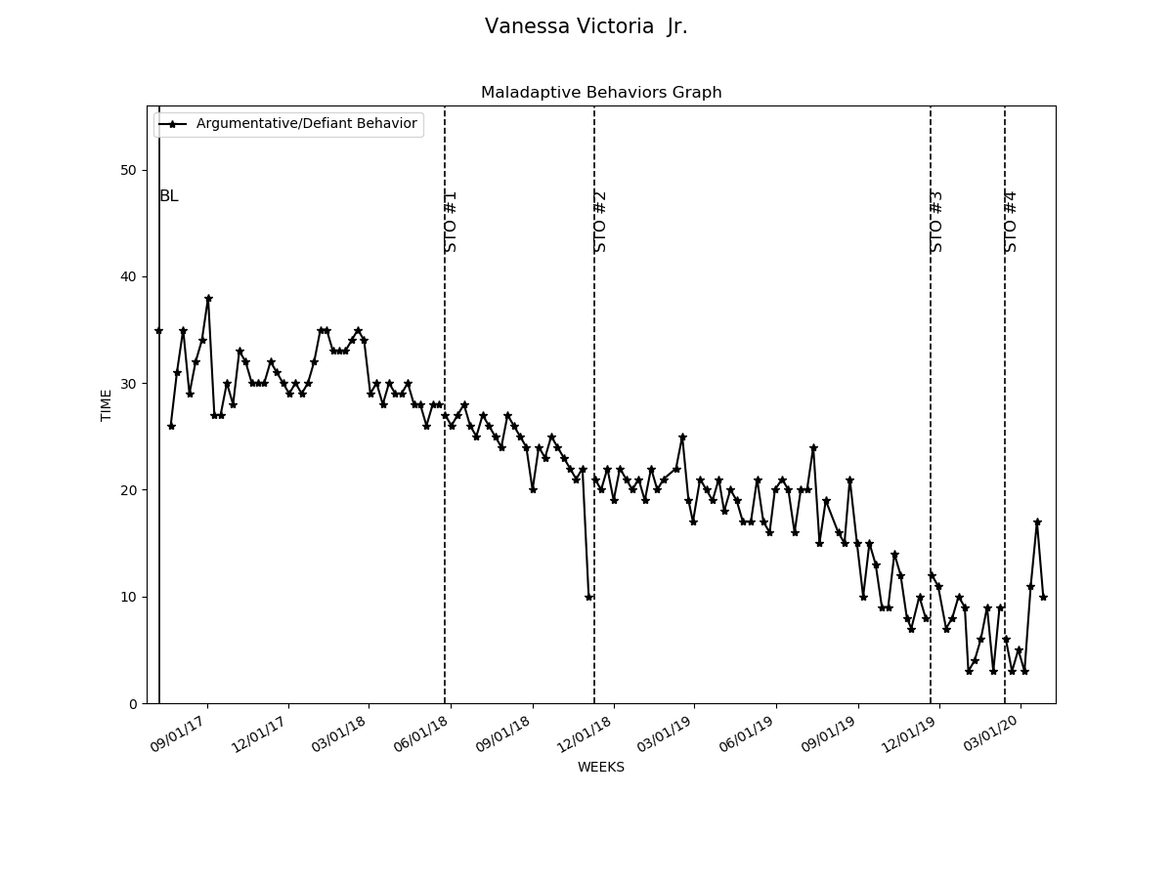

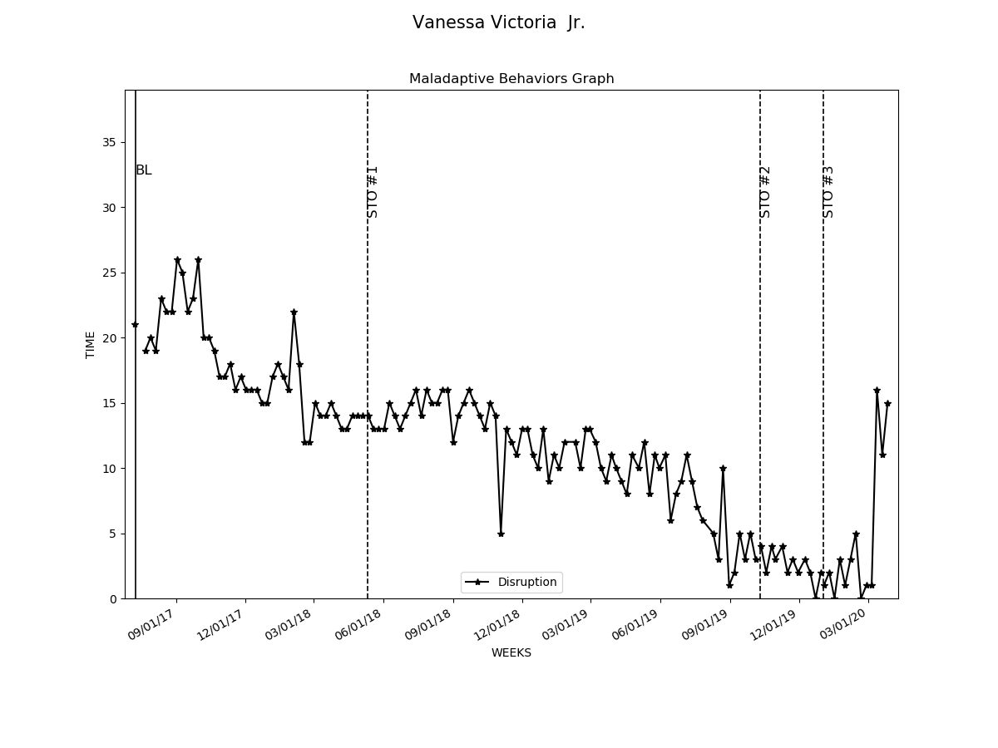

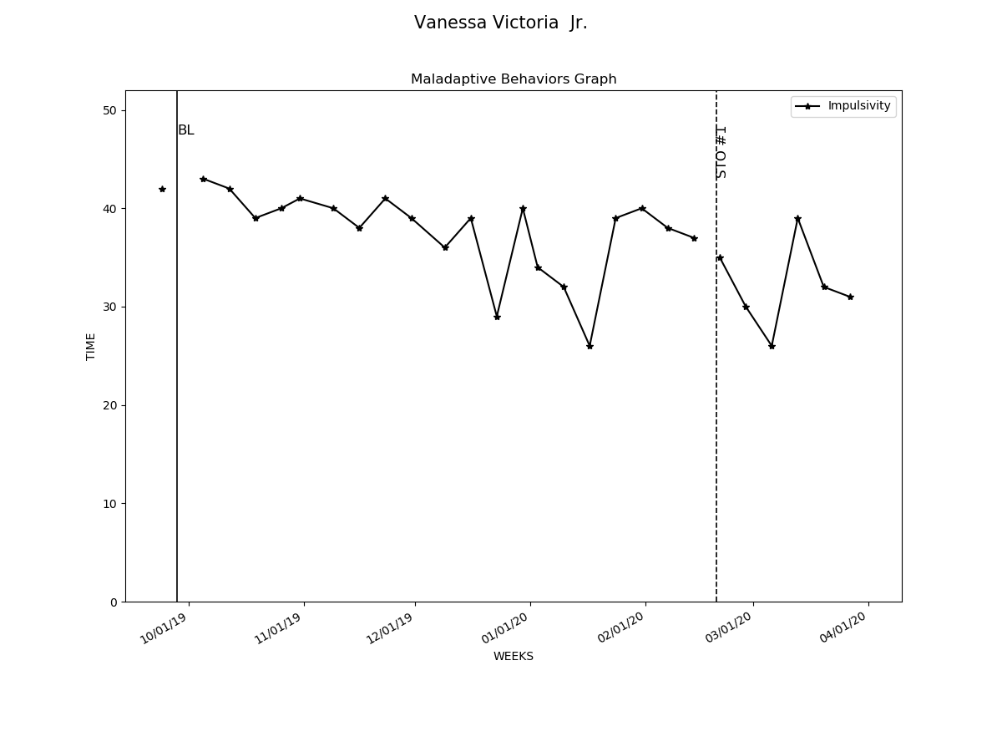

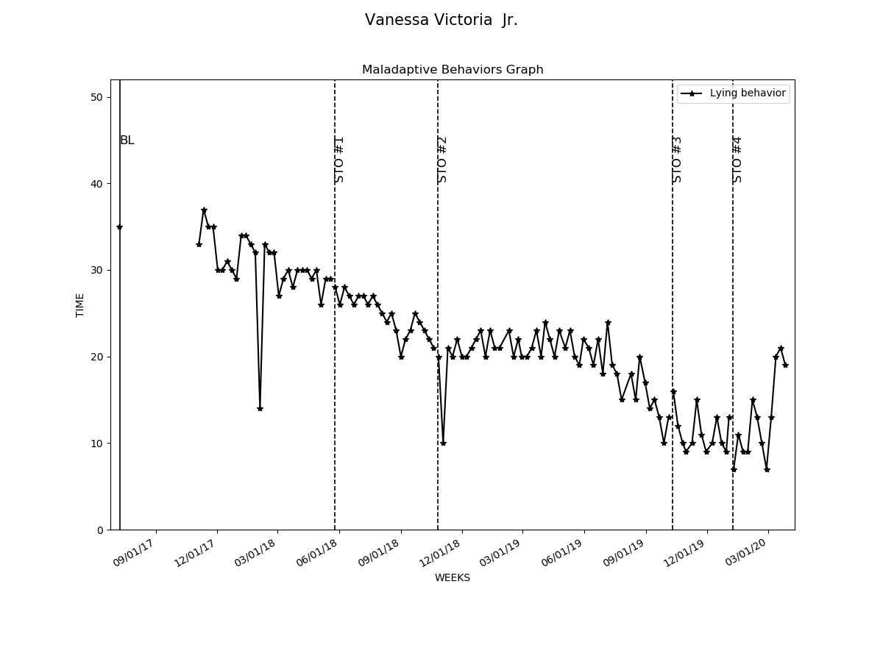

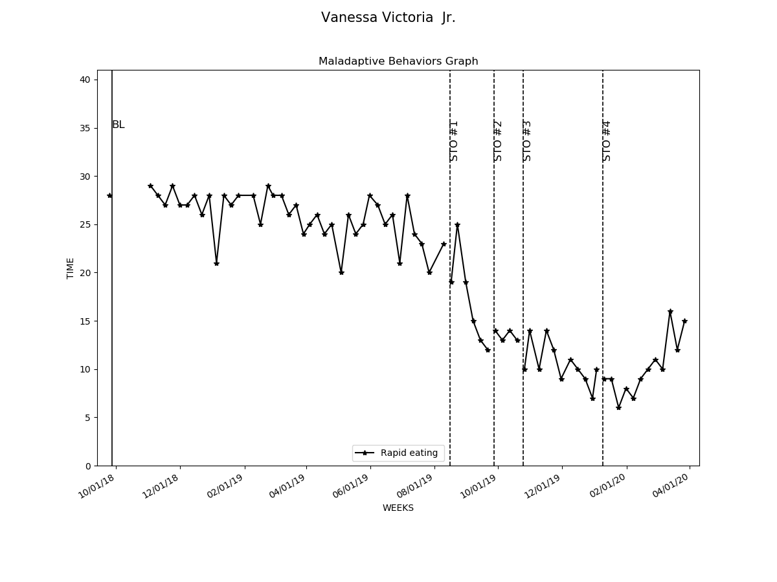

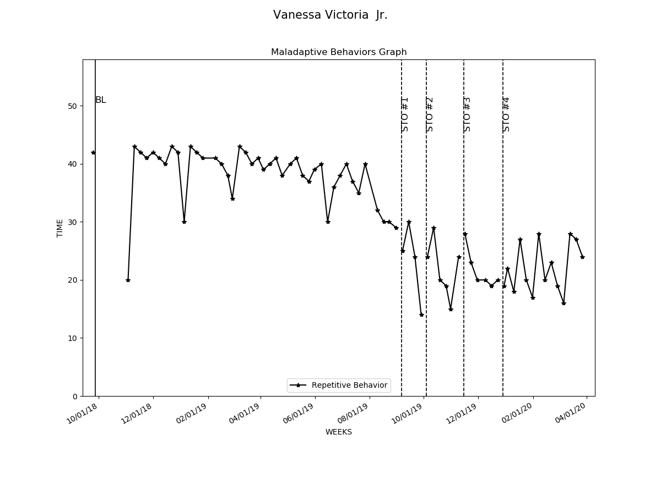

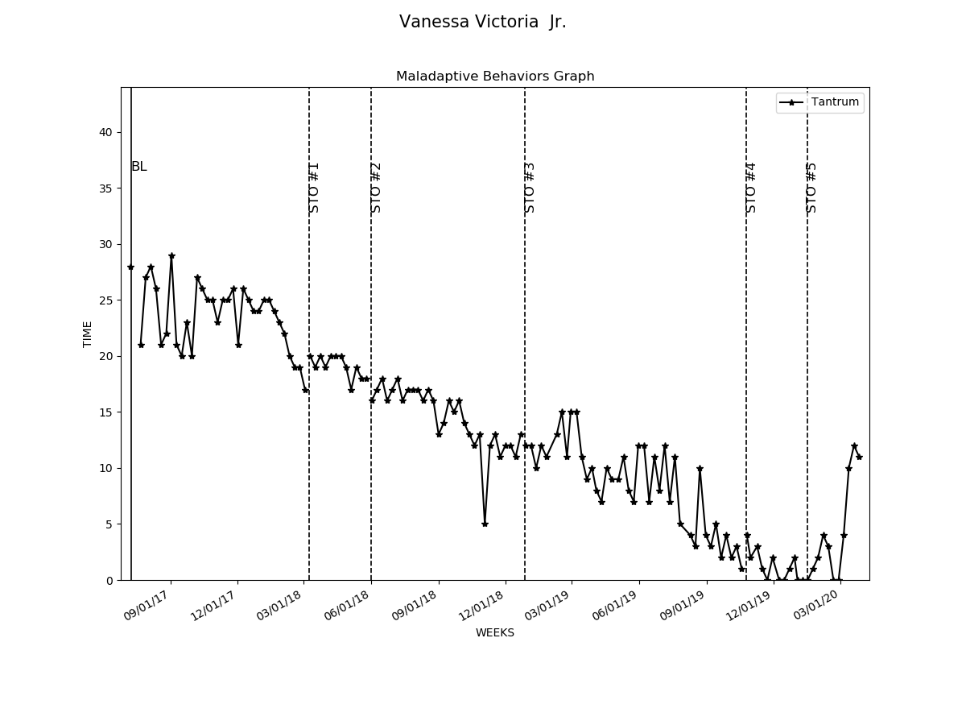

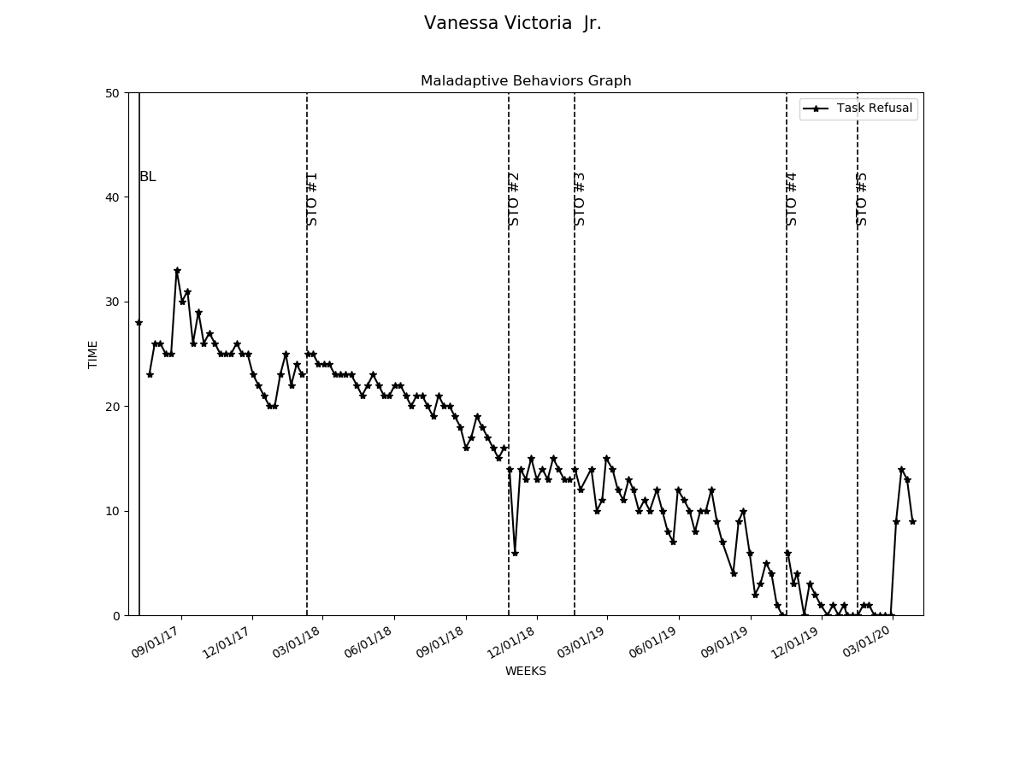

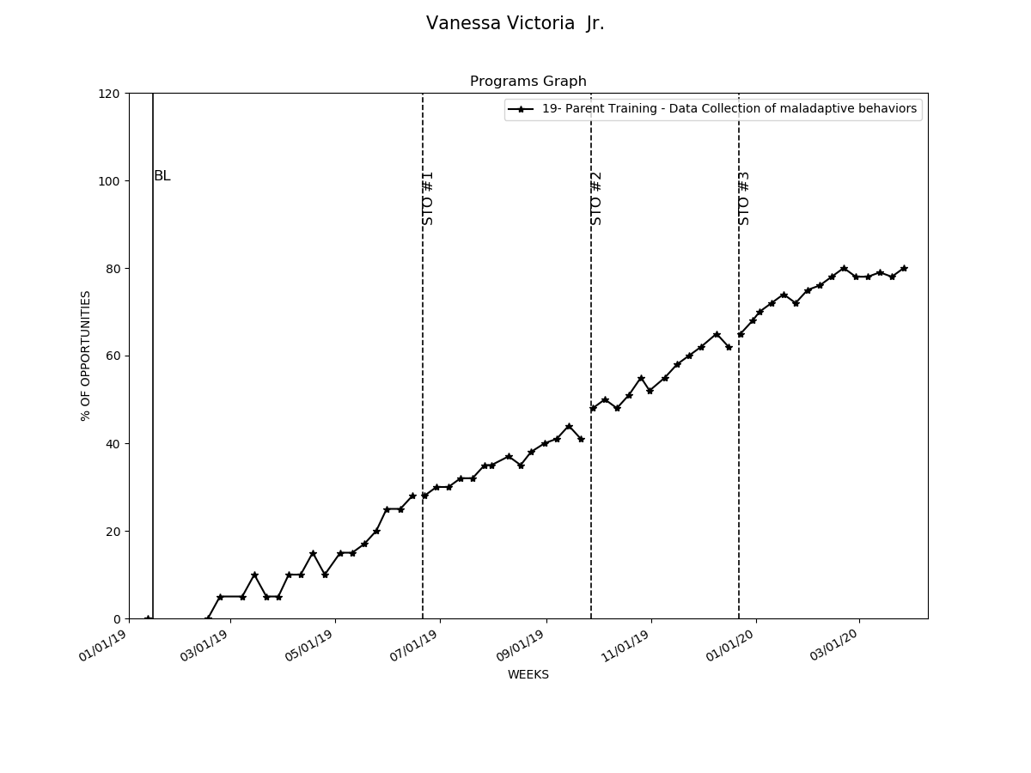

# Graphs Replacement and Interventions

|  |  |  |  |  |
| --- | --- | --- | --- | --- |
| Replacements and Programs | Baseline Date:2017-07-22to2017-07-25 | Current average per week (3/31/2020) | Status | Updated STO (3/31/2020) |
| 1- Request Break | 10% | 69% | In progress | Sto1(MASTERED 2018-01-13). Sto2(MASTERED 2018-07-21). Sto3(MASTERED 2019-06-08). Currently: STO 4(Initiated 7/1/2019) |
| 2- Request Attention | 10% | 71% | In progress | Sto1(MASTERED 2018-01-13). Sto2(MASTERED 2018-07-21). Sto3(MASTERED 2019-06-08). Currently: STO 4(Initiated 7/1/2019) |
| 3- Request Tangible | 10% | 67% | In progress | Sto1(MASTERED 2018-01-20). Sto2(MASTERED 2018-07-21). Sto3(MASTERED 2019-06-08). Currently: STO 4(Initiated 7/1/2019) |
| 4- Follow instructions | 10% | 63% | In progress | Sto1(MASTERED 2018-01-20). Sto2(MASTERED 2018-07-21). Sto3(MASTERED 2019-06-15). Currently: STO 4(Initiated 7/1/2019) |
| 5- Night Time Routine | 10% | 71% | LTO in progress | Sto1(MASTERED 2018-01-20). Sto2(MASTERED 2018-07-21). Sto3(MASTERED 2019-05-18). Sto4(MASTERED 2020-02-14). |
| 7- Interrupt conversation appropriately | 10% | 63% | In progress | Sto1(MASTERED 2018-01-20). Sto2(MASTERED 2018-07-21). Sto3(MASTERED 2019-05-18). Currently: STO 4(Initiated 6/1/2019) |
| 8- Social Skills- Sustain interaction | 10% | 71% | In progress | Sto1(MASTERED 2018-01-20). Sto2(MASTERED 2018-07-21). Sto3(MASTERED 2019-05-18). Currently: STO 4(Initiated 6/1/2019) |
| 9- Social Skills- Takin turns during a play | 8% | 81% | LTO in progress | Sto1(MASTERED 2018-01-20). Sto2(MASTERED 2018-07-21). Sto3(MASTERED 2019-05-31). Sto4(MASTERED 2020-03-20). |
| 10- Social Skills- Sharing toys | 10% | 83% | LTO in progress | Sto1(MASTERED 2018-01-13). Sto2(MASTERED 2018-07-21). Sto3(MASTERED 2019-07-31). Sto4(MASTERED 2020-03-13). |
| 13- Clean and organize room | 10% | 65% | In progress | Sto1(MASTERED 2018-01-20). Sto2(MASTERED 2018-07-21). Sto3(MASTERED 2019-08-31). Currently: STO 4(Initiated 9/1/2019) |
| 14- Wait for Tangible | 3% | 66% | In progress | Sto1(MASTERED 2018-01-20). Sto2(MASTERED 2018-07-21). Sto3(MASTERED 2019-05-25). Currently: STO 4(Initiated 6/1/2019) |
| 19- Parent Training - Data Collection of maladaptive behaviors | 0% | 79% | In progress | Sto1(MASTERED 2019-06-15). Sto2(MASTERED 2019-09-21). Sto3(MASTERED 2019-12-16). Currently: STO 4(Initiated 1/1/2020) |
| 20- Parent Training - Generalization of skills | 0% | 75% | In progress | Sto1(MASTERED 2019-06-15). Sto2(MASTERED 2019-10-05). Sto3(MASTERED 2019-12-23). Currently: STO 4(Initiated 1/1/2020) |
| 21- Eating slowly | 25% | 22% | In progress | Sto1(MASTERED 2020-01-17). Currently: STO 2(Initiated 2/1/2020) |

